**Hybrid Analytic–Monte Carlo Collision-Probability Filter for DebriSolver CDMs**

Abdullah I, AlGharrash 1, Fatima Alhazmi2, Fatimah Sammar3, Sedra Abdul Basir 4, Muhammad Shahid 5

1 Saudi Space Community; Alolayya district, Khobar, Saudi Arabia, Gharrash124@gmail.com

2Department of Physics, King Fahd University of Petroleum and Minerals (KFUPM); Dhahran 31261, Saudi Arabia, g202318130@kfupm.edu.sa

3 Alsalam for Training & Education; Alolayya district, Khobar, Saudi Arabia, fatsammar@gmail.com

4 Taibah University; Janadah Bin Umayyah Road, Madinah, Saudi Arabia, sedra.abdulbasir@gmail.com

5 Tech Nordics, Skogaberg 81, 42249, Gothenburg, Sweden, shahid@technordics.se

# **Abstract**

As Low Earth Orbit (LEO) becomes more crowded, operators receive a growing number of Conjunction Data Messages (CDMs) that report possible close approaches between their satellites and other objects. Many alerts carry large uncertainty, so standard analytic collision-probability tools can generate high-risk warnings that later drop below action thresholds as more tracking data arrives. This paper presents a compact hybrid framework that combines a fast encounter-plane analytic method with automatic validity checks and a targeted Monte Carlo (MC) refinement step. We analyse 185,511 CDMs for a LEO constellation over a 14-day window. First, we use the catalog-supplied analytic probability of collision to define a “physics red zone” of events with Pc > 10⁻⁴. Next, we compute three simple geometric and dynamical gates in the encounter plane (size ratio, near-tangency, and a curvature metric). Any event that is in the red zone or fails at least one gate is re-evaluated with a two-dimensional MC model that samples the relative position uncertainty in the encounter plane and counts hits inside the combined hard-body radius. Out of 2,750 analytic red-zone events, only 2,428 remain above $Pc,MC$ > 10⁻⁴ after encounter-plane MC re-evaluation, meaning 322 events (11.7 % of the analytic red zone) are downgraded below the threshold. We also find 530 “nightmare” events with $Pc,MC$ > 10⁻⁴ and less than 24 h of warning, about half of which are caused by other active payloads rather than debris. The proposed filter tightens conjunction risk estimates while keeping the workflow simple, transparent, and compatible with current CDM-based operations.

**Keywords:** Collision probability; Monte Carlo; space debris; conjunction assessment; mega-constellations.

# **Introduction**

The number of active satellites in Low Earth Orbit (LEO) is growing quickly as large constellations, rideshare launches, and new national programmes share the same orbital shells. Even if all launches stopped today, debris models show that collisions and explosions would continue to add fragments to the environment for decades [1]–[3], [11]–[13]. For operators this growth appears as a constant stream of Conjunction Data Messages (CDMs) that flag possible close approaches between their spacecraft and other objects.

These alerts are necessary, but they are noisy. A CDM is built from tracking data that has non-trivial errors in position, velocity, and drag. Covariance information is often incomplete or optimistic. Catalog maintenance and manoeuvres introduce jumps in the ephemerides. As a result, the collision probability reported in a CDM can change by orders of magnitude as more data is collected. Operators must decide whether and when to manoeuvre while the numbers are still moving.

The most widely used tools for assessing collision risk are encounter-plane analytic methods such as those of Akella and Alfriend and Patera [6], [7], [15]–[17], [24]. They combine the two position covariance matrices at the time of closest approach (TCA), rotate them into a local encounter frame, and integrate a two-dimensional Gaussian over a circular hard-body region. These formulas are attractive because they are fast and easy to implement. However, they rely on several assumptions: short encounter duration, roughly linear relative motion, and an uncertainty ellipse that is large compared to the physical size of the objects. When these assumptions are violated, the analytic probability of collision can be biased high or low.

Monte Carlo (MC) methods avoid many of these issues by sampling directly from the full uncertainty distribution and counting how many trial trajectories pass within the combined hard-body radius [4], [5], [16], [17], [19], [20]. MC is flexible and physically intuitive, but it has a cost: running large numbers of samples for every CDM is expensive, especially when it is very small. For this reason most operational systems still rely on analytic formulas alone.

Our goal in this work is to keep the speed of the analytic methods while recovering most of the robustness of MC. We build a small hybrid filter that (i) accepts the catalog-supplied analytic $P_{c}$ as a starting point, (ii) checks whether the assumptions behind that $P_{c}$ are valid using simple geometric and dynamical metrics, and (iii) runs a focused MC calculation in the encounter plane only for those encounters that are either analytically high-risk or geometrically suspect. The filter is designed to be transparent, with clear thresholds and outputs that can be traced back to the CDM fields.

Using a dataset of 185,511 CDMs for a LEO constellation over 14 days, we quantify how many alerts fall into a “physics red zone” (Pc > 10⁻⁴), how often the validity gates are triggered, and how the analytic and MC probabilities compare. We also look at the warning time and the type of threat object to understand which encounters are most operationally stressful. The results show that a simple hybrid filter can downgrade a significant fraction of analytic high-risk alerts when re-evaluated with encounter-plane MC, while keeping the overall process compatible with current operational practice.

Prior Pc work spans pure analytic encounter-plane formulas, full Monte Carlo estimators; and hybrid screening+MC refinement used in operational practice. Our contribution is a CDM-only filter with minimal, interpretable gates (η size ratio, tangency T, curvature ρ) tuned for operations, validated on 185,511 CDMs, and showing an 11.7% reduction of red-zone false positives.

# **Methodology**

We describe the data, pre-processing, analytic screening, the three validity gates, and the encounter-plane Monte Carlo (MC) model. The method can be reproduced from the Conjunction Data Messages (CDMs) alone.

## *2.1 Data and pre-processing*

We use 185,511 CDMs drawn from a Low Earth Orbit (LEO) constellation over a 14-day window. Each CDM follows the CCSDS Conjunction Data Message (CDM) format [10] and contains, at the time of closest approach (TCA), a Cartesian state vector and 10×10 covariance matrix for each object, plus metadata such as object type, catalog identifiers, and hard-body radius (HBR) when available.

The first step is basic cleaning. We strip column names, convert numeric fields to floating-point values, and parse time stamps into UTC datetimes. Columns that are entirely empty are removed. For each object we compute a hard-body radius using a simple policy: if the CDM provides an HBR value, we keep it; otherwise we assign 2 m to payloads and rocket bodies and 1 m to generic debris. The combined collision radius used in all calculations is

$$R_{coll}={HBR}_{1}+{HBR}_{2}.$$

We also compute derived quantities from CDM fields: the relative position and velocity, their magnitudes, the approach angle between them, and the warning time (TCA minus CDM creation time).

## *2.2 Analytic screening and the physics red zone*

The catalog provider supplies an analytic probability of collision in each CDM, computed with an encounter-plane method in the spirit of Akella–Alfriend and Patera [6], [7]. This is produced by an encounter-plane method that combines the position covariances and , rotates them into a local frame where the third axis is aligned with the relative velocity, and evaluates the integral of a two-dimensional Gaussian over a circle of radius in the encounter plane [8], [9]. Numerical quadrature methods can extend this integration to arbitrary hard-body shapes [25].

We assume Gaussian, independent catalogue position errors, so the relative covariance is the sum of both objects’ covariances. Because both the analytic Pc and our encounter-plane MC Pc,MC use a 2D Gaussian model at TCA, this paper does not model nonlinear relative motion or covariance evolution during the encounter; some long-duration or poorly observed events may require higher-fidelity propagation. We do not recompute this analytic $P_{c}$; instead we treat it as an input and define a physics red zone of events where

$$P_{c}>{10}^{-4}.$$

Only 2,750 CDMs (about 1.5 % of the dataset) fall into this red zone. In an analytic workflow, all of these events would usually be treated as high-risk. Our aim is to identify which of them truly require action and which are artefacts of violated assumptions.

## *2.3 Encounter-plane geometry and validity gates*

To diagnose the geometry we reconstruct the relative state and in-plane uncertainty directly from CDM fields. Let $r_{1},v_{1}$ and $r_{2},v_{2}$ be the position and velocity vectors of the two objects at TCA, and let $C_{1}$ and $C_{2}$ be their $3×3$ position covariance matrices in the RTN frame. The relative position and velocity are

$$r_{rel}=r_{2}-r_{1}, v_{rel}=v_{2}-v_{1},$$

and the relative position covariance is

$$C_{rel}=C_{1}+C_{2}.$$

We define an encounter frame whose third axis ${\hat{e}}_{3}$ is aligned with $v_{rel}$ and whose first two axes ${\hat{e}}_{1},{\hat{e}}_{2}$ span the plane perpendicular to ${\hat{e}}_{3}$. With rotation matrix $R$ formed from these unit vectors, we obtain the encounter-frame covariance

$$C'_{rel}=R C_{rel} R^{T}.$$

The in-plane covariance $Σ$ is the upper-left $2×2$ block of $C'_{rel}$, and the in-plane miss vector $μ$ is given by the first two components of $R r_{rel}$. The eigenvalues of $Σ$ define the major and minor one-sigma axes of the uncertainty ellipse, $σ_{major}$ and $σ_{minor}$.

From these quantities we build three validity gates:

* **Size ratio**
$$η=\frac{R_{coll}}{σ_{minor}}.$$

* If $η$ is larger than about $0.6$, finite object size is no longer small compared to dispersion and the point-particle assumption becomes weak.
* **Tangency metric**
* $T=\left|cosθ_{app}\right|,$ ere $θ_{app}$ is the angle between $μ$ and the in-plane projection of $v_{rel}$. Values $T>0.95$ correspond to near-tangent encounters where small geometry errors change $P_{c}$ strongly.
* **Curvature metric $ρ$** . We approximate an effective encounter duration
$$τ≈\frac{2\sqrt{σ_{major}σ_{minor}}}{∥v_{rel}∥},$$

* and multiply by the mean motion $n$ to obtain
$$ρ=n τ.$$

* Large values ($ρ>0.2$) indicate that the constant-velocity (straight-line) assumption may be weak; in this paper we use ρ as a conservative flag for MC and as a marker for cases where higher-fidelity propagation would be preferable.

Any CDM that lies in the physics red zone or fails at least one gate ($η>0.6$, $T>0.95$, or $ρ>0.2$) is flagged for Monte Carlo refinement.

## *2.4 Encounter-plane Monte Carlo model*

For each flagged CDM we construct the same encounter-plane mean $μ$ and covariance $Σ$. We then draw $N$ random in-plane samples $z_{i}$ from the bivariate normal distribution $N\left(μ,Σ\right)$. For each sample we compute its distance from the origin and count a hit when $∥z_{i}∥<R_{coll}$. If $K$ out of $N$ samples fall inside the circle, the Monte Carlo probability of collision is

$$P_{c}^{MC}=\frac{K}{N}.$$

We use 100,000 samples in the main experiments, which gives a 95 % binomial confidence interval with relative half-width of order 0.2–0.6 for Pc in the 10⁻⁴–10⁻³ range. All computations are implemented in Python using NumPy and Pandas, with simple parallelism across CPU cores.

# **Results & Discussion**

This section presents the main results of applying the hybrid filter to the constellation dataset. We first describe the traffic mix, then compare analytic and Monte Carlo (MC) probabilities, and finally examine timing and threat types.

## *3.1 Traffic profile*

The 185,511 CDMs in the sample cover a mix of internal constellation encounters and external threats. Using the object-type fields in the CDMs we classify each conjunction into three high-level categories:

* Payload versus Payload: both objects are active satellites.
* Payload versus Debris or Rocket Body: the primary is active and the secondary is environmental.
* Other pairs: all remaining combinations.

Payload-versus-payload encounters dominate the stream. There are 132,639 such CDMs, which is 71.5 % of the dataset. Payload-versus-debris or rocket-body encounters account for 9,109 CDMs (4.9 %). The remaining 43,763 CDMs (23.6 %) are in the “other pairs” class, which includes events where the monitored object is not the constellation payload.

This breakdown shows that, for a large LEO constellation, most alerts are internal to the constellation. Debris is important but does not dominate day-to-day workload. A useful filter must therefore be able to treat these two classes in a consistent way while allowing operators to set different manoeuvre policies for internal and external risks.

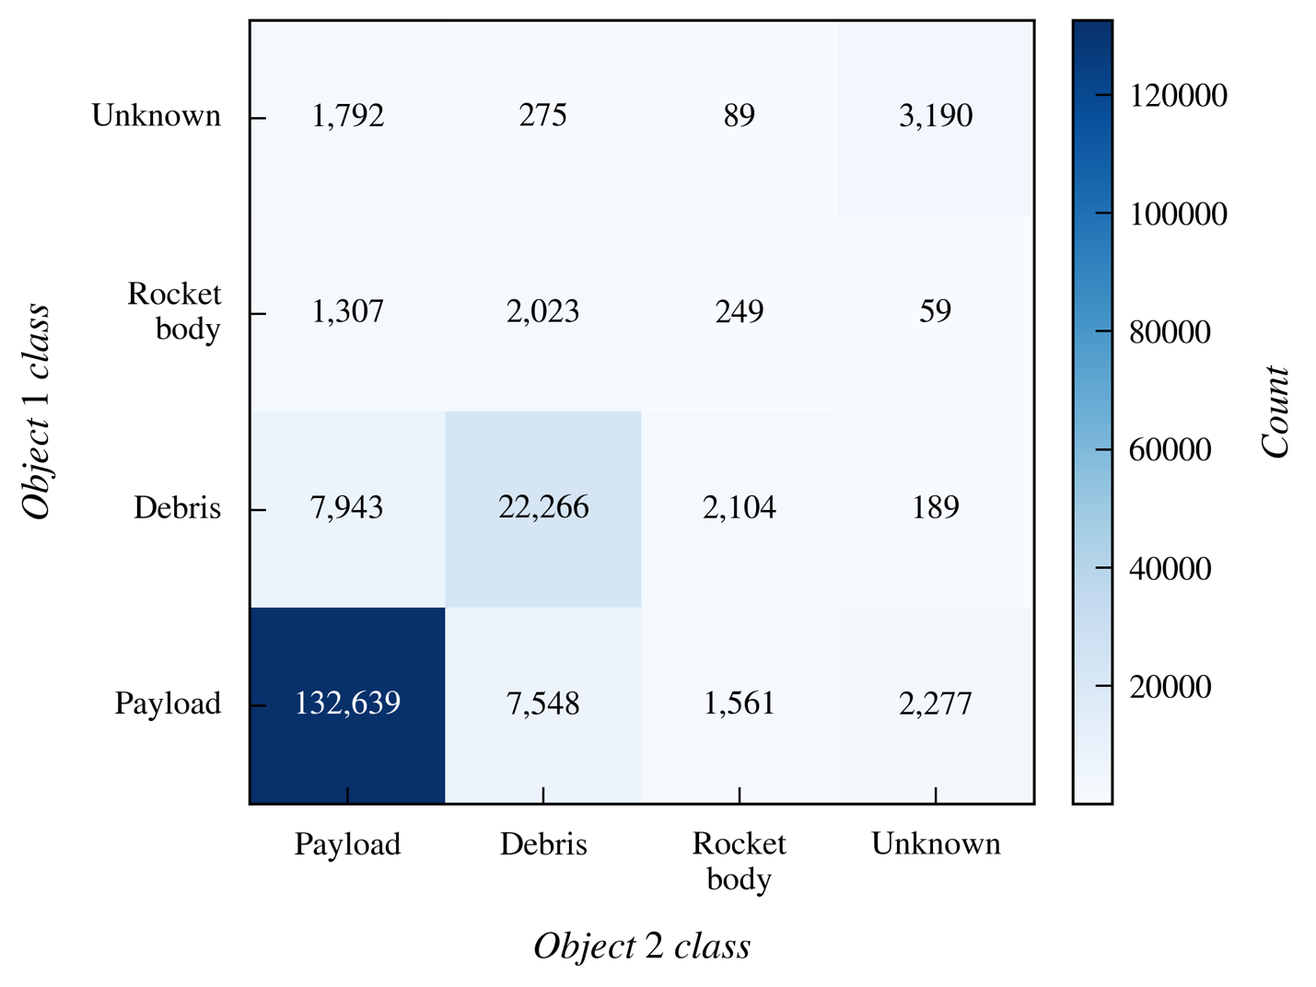

Figure 1: Conjunction interaction matrix for the full CDM set.

Figure 1 shows the same breakdown as a heatmap of object-type pairs. The strong diagonal PAYLOAD–PAYLOAD block makes the dominance of internal traffic visually clear.

## *3.2 Gate behaviour and selection of events for Monte Carlo*

We next examine how many events pass each validity gate and how many are sent to MC. Out of the 185,511 CDMs, 2,750 have analytic Pc above the physics red-zone threshold of 10⁻⁴. These are the events that would normally be treated as high-risk.

When we apply the three encounter-plane gates across all CDMs with complete covariance information, about one third of the stream fails at least one gate. Large size ratios $η$ often occur when the in-plane dispersion is tight but the objects have relatively large hard-body radii. Tangency failures ($T>0.95$) are less common but are strongly associated with grazing passes where the miss vector and relative velocity are almost aligned. Curvature failures ($ρ>0.2$) appear mainly for slow relative motion and for orbits at lower altitudes, where stronger drag and Earth’s oblateness perturb the dynamics.

Combining the red-zone flag and the gate results, 65,562 CDMs (about 35 % of the dataset) are routed to the MC stage. This may seem like a large fraction, but the computation is still tractable: with 100,000 samples per event and simple parallelisation, the full run completes in a few minutes on a modern workstation. The remaining roughly two thirds of the stream retain their analytic Pc and are labelled “Analytic/OK”.

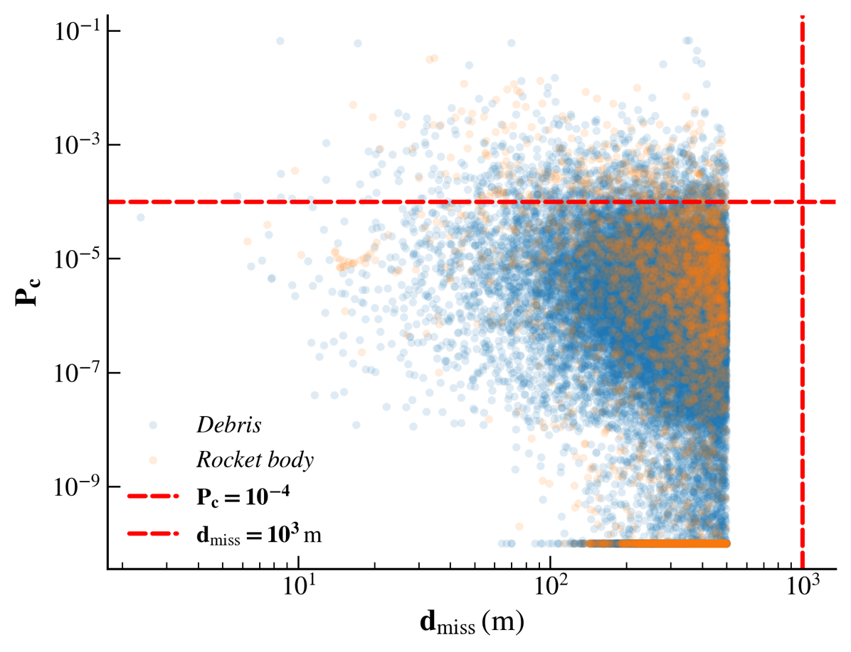

Figure 2: Miss distance versus catalog analytic collision probability for all CDMs (log–log axes).

Figure 2 plots the catalog analytic Pc against miss distance for the full dataset. Most encounters fall well below the 10⁻⁴ threshold, and the red-zone events form a compact cloud at small miss distances.

## *3.3 Analytic versus Monte Carlo red-zone events*

The key test for the hybrid filter is how many analytic high-risk events remain above the threshold after MC refinement. Among the 2,750 red-zone CDMs, the MC model confirms only 2,428 as having Pc,MC > 10⁻⁴. In other words, 322 events (11.7 % of the analytic red zone) are downgraded once sampling is used. These are cases where the encounter geometry or covariance shape violates the assumptions behind the analytic formula.

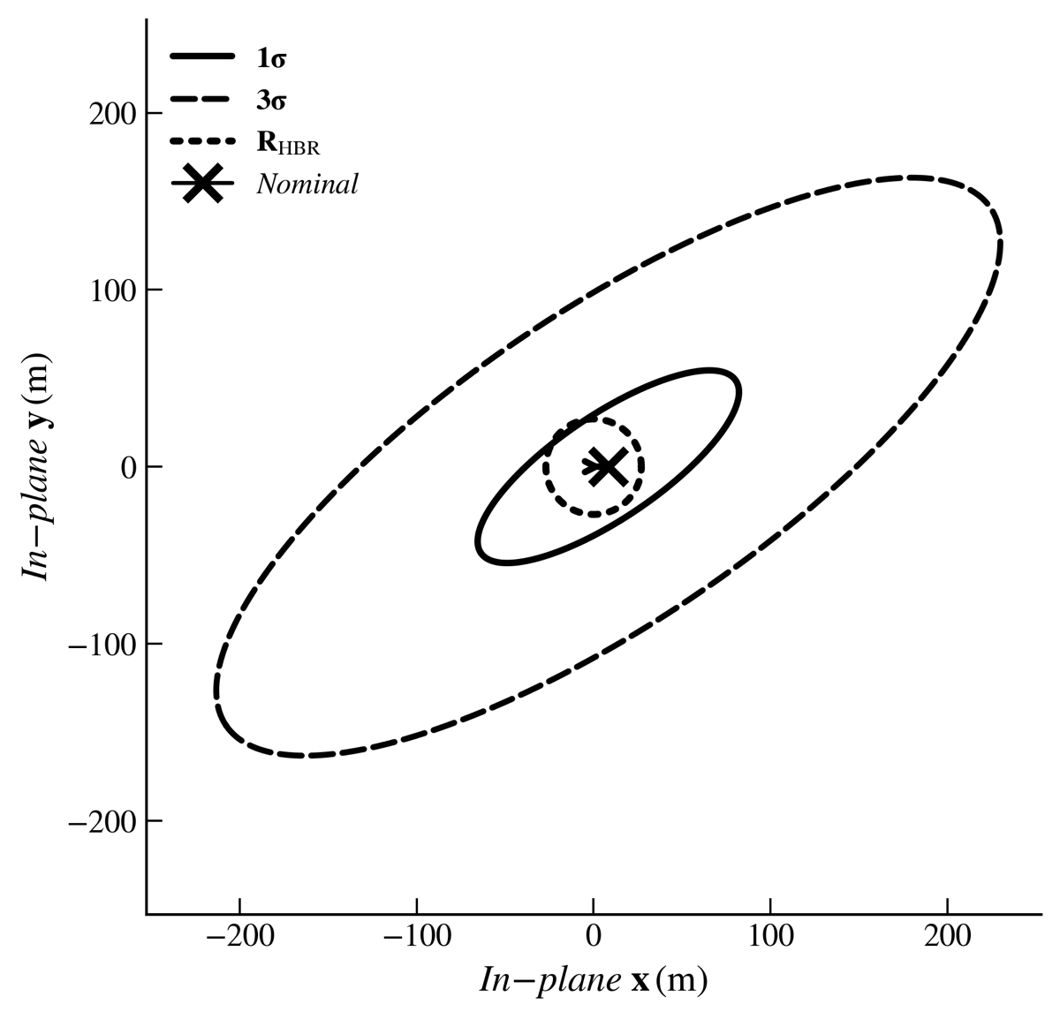

Figure 3: Encounter-plane geometry at TCA for a representative high-risk conjunction.

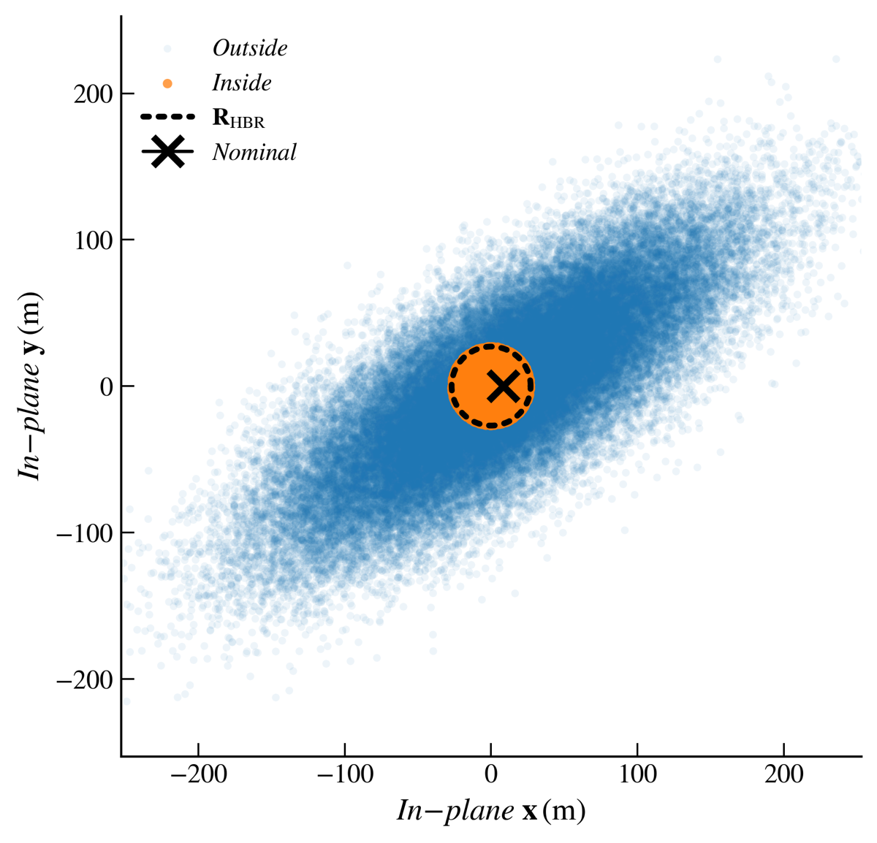

Figure 4: Monte Carlo samples in the encounter plane for the same conjunction as Figure 3.

Figure 3 shows the encounter-plane geometry for one high-risk conjunction, and Figure 4 shows the corresponding Monte Carlo samples in the same plane. Together they illustrate how the analytic ellipse and the sampled cloud agree when the encounter-plane assumptions are satisfied.

In contrast, many of the downgraded events have large size ratios, near-tangent approach metrics, or large curvature values. In these cases the analytic $P_{c}$ can be biased high because the projected two-dimensional geometry overstates the overlap between the uncertainty ellipse and the collision circle. The MC model, which samples directly from the in-plane distribution, reveals that few realizations actually cross into the hard-body region.

## *3.4 Timing and “nightmare” events*

To assess operational urgency we compute a warning time for each CDM as the difference, in hours, between the TCA and the CDM creation time. Most alerts arrive well in advance. However, there is a non-negligible tail of late warnings.

We define a nightmare event as any conjunction with Pc,MC > 10⁻⁴ and warning time less than 24 h. In the dataset there are 530 such events. Active payloads account for 267 nightmare events (about 50 %), debris for 207 events (39 %), rocket bodies for 48 events (9 %), and the remainder (8 events, 1.5 %) fall into an “Unknown” class.

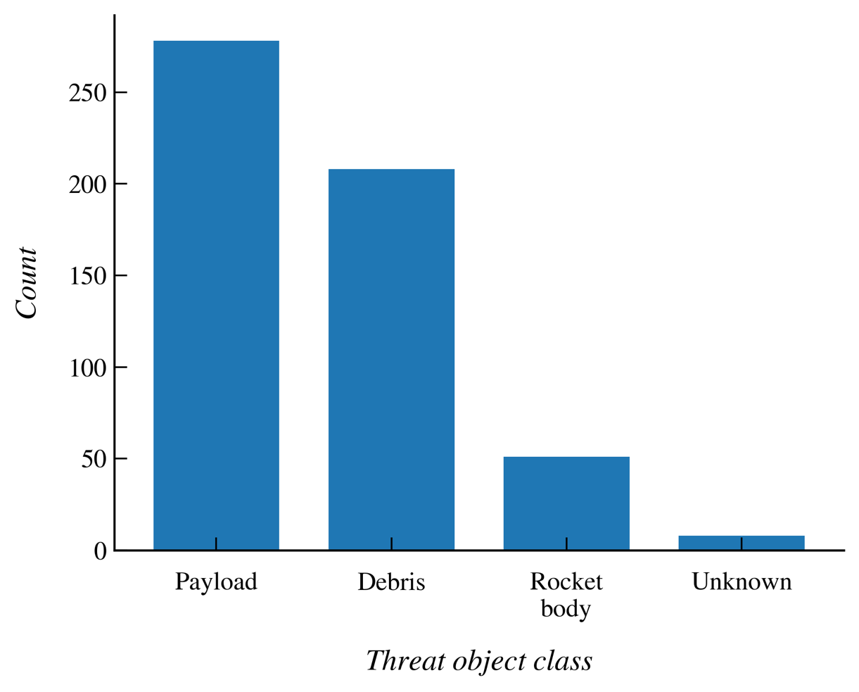

Figure 5: Distribution of confirmed nightmare events (Pc,MC > 10⁻⁴ and warning time < 24 h) by threat-object class.

Figure 5 summarises these nightmare events by threat-object type. It shows that, at least for this constellation and time window, late high-risk alerts are more often caused by other active satellites than by debris. In many cases the root cause is an unshared manoeuvre: the threat satellite performs a thrust or orbit change that is not immediately reflected in the public catalog, and once it is re-acquired its new trajectory produces a sudden conjunction for the constellation.

Technical tools such as the hybrid filter can reduce false alerts, but solving the nightmare-event problem will also require better sharing of manoeuvre plans between operators. [22]–[27].

## *3.5 Threat sources and parameter correlations*

To understand which physical objects dominate the residual risk we look at those CDMs that remain above the 10⁻⁴ threshold after MC validation. The most frequent contributors include FENGYUN 1C debris (192 encounters), DELTA 1 debris (97), SL-8 rocket bodies (87), NOAA 16 debris (75), SHIYAN 24C 03 (72), COSMOS 2251 debris (56), TerraSAR-X (54), CZ-6A debris (41), H-2A rocket bodies (34), and THORAD AGENA D debris (33). Many of these names reflect well-known fragmentation events that have produced dense debris clouds in popular orbital planes. The active payloads in this list are typically Earth-observation spacecraft whose manoeuvres or orbit adjustments are not always visible to other operators in real time. Finally, we examine how basic scalar parameters relate to the MC collision probability. As expected, Pc,MC is weakly anticorrelated with miss distance and positively correlated with the combined hard-body radius. Its correlation with relative speed and approach angle is small at catalog level, because many different geometries can produce the same speed or angle. The strongest off-diagonal term in the matrix is the negative correlation between relative speed and the combined hard-body radius, reflecting the fact that large, low-altitude rocket bodies and debris clouds tend to have lower relative speeds against the constellation.

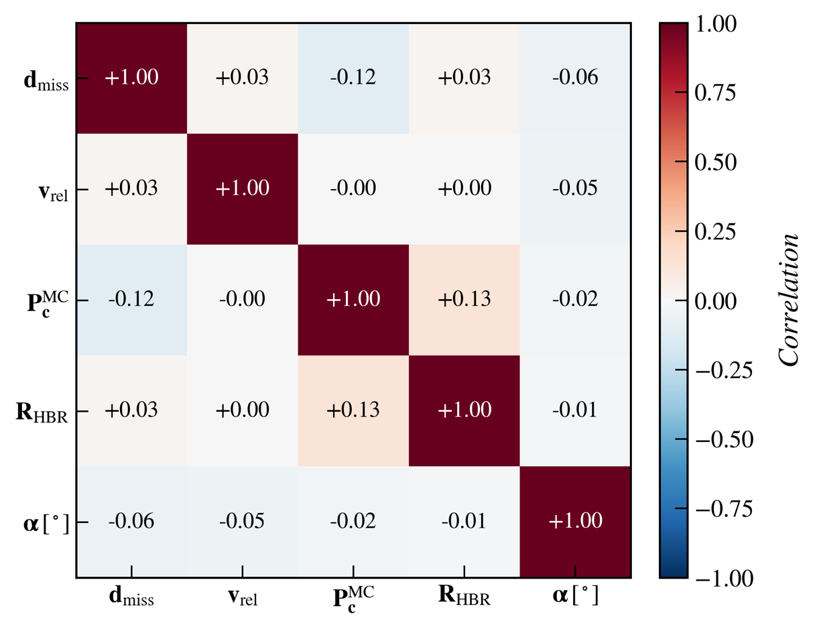

Figure 6: Figure 6: Correlation matrix of selected CDM features: miss distance, relative speed, Monte Carlo collision probability, combined hard-body radius, and approach angle.

Figure 6 shows this correlation matrix. Overall, the results (Table 1) demonstrate that a simple hybrid filter based on encounter-plane geometry and a focused MC step can reduce false positives in the high-risk subset, expose the true mix of internal and external threats, and highlight where non-technical measures such as data sharing would further improve safety.

|  |  |
| --- | --- |
|  | **Count** |
| Total CDMs | 185,511 |
| Analytic Red-Zone (Pc > 1e-4) | 2,750 |
| Sent to MC (Red-zone or Borderline) | 65,562 |
| MC Confirmed High-Risk (Pc > 1e-4) | 2,428 |
| Downgraded (Analytic Red, MC Not) | 322 |
| Nightmare Events (MC Pc > 1e-4 & warning < 24h) | 530 |

Table 1: Summary of conjunction event filtering and risk validation

# **Conclusion**

This paper presented a practical hybrid framework for conjunction risk assessment in Low Earth Orbit. Starting from 185,511 Conjunction Data Messages (CDMs) for a LEO constellation, we combined the catalog-supplied analytic probability of collision with three simple encounter-plane validity gates and a targeted Monte Carlo (MC) refinement step. The method keeps the standard encounter-plane formulation at its core. We accept the analytic Pc values produced by existing tools but test whether their assumptions hold using size-ratio, tangency, and curvature metrics derived from the in-plane covariance and geometry. Only events that are analytically high-risk (Pc>10-4) or that fail at least one gate are re-evaluated with a two-dimensional MC model in the encounter plane. This design keeps the filter fast while focusing computational effort on the most ambiguous encounters. Applied to the Aldoria dataset, the hybrid filter routed about one third of all CDMs to the MC stage and left the rest with their analytic Pc and an “Analytic/OK” label. Among the 2,750 analytic red-zone events, only 2,428 remained above the risk threshold after MC validation, corresponding to an 11.7 % reduction in false positives within the most critical subset. We also identified 530 “nightmare” events with Pc,MC > 10⁻⁴ and less than 24 h of warning, over half of which were caused by other active payloads rather than debris or rocket bodies.

These findings have two main implications. First, even a lightweight MC step applied to a carefully selected subset of alerts can materially improve confidence in collision-risk estimates without breaking operational timelines. Second, many of the most urgent threats in this dataset are not environmental fragments but other active satellites whose manoeuvres are not fully shared. Better technical tools and better coordination must go hand in hand. [19], [23]–[25]. Future work will extend the framework in two directions. On the physics side we plan to couple the encounter-plane model with uncertainty in atmospheric density and drag, which is important for high-area-to-mass objects. On the operations side we plan to add a simple machine-learning triage layer [29] that learns from historical CDMs to predict which alerts are likely to be false positives before MC is run, while keeping the model small and interpretable. Overall, the hybrid analytic–Monte Carlo filter offers a realistic path toward safer and more efficient collision-risk management for large constellations in an increasingly crowded LEO environment.

# **Acknowledgment**

This work was carried out as part of the Saudi Space Agency DebriSolver competition. We thank the competition organizers for defining a clear and challenging use case and Aldoria for providing access to CDM data and technical clarifications. Lastly, I would like to extend my heartfelt gratitude to my teammates for their unwavering dedication, hard work, and commitment throughout this project.

# **Appendix**

## *6.1 Reproducibility and code*

The full analysis workflow (data loading, preprocessing, figures, and the hybrid analytic–Monte Carlo filtering notebooks) is available in our public repository at <https://github.com/siudro/Robust-Probability-of-Collision-for-Space-Operations>  
The repository contains the Jupyter notebooks used to generate the reported counts and plots, along with scripts to reproduce the encounter-plane gates and Monte Carlo estimates from the CDM fields.

## *6.2 Encounter-Plane Formulation, Gates, and Monte Carlo Estimator*

Each CDM provides a $6×6$ covariance matrix $P_{k}$ for object $k$, written in block form as

$$P_{k}=\left(C_{rr,k} C_{rv,k} C_{vr,k} C_{vv,k} \right),$$

where $C_{rr,k}$ is the $3×3$ position covariance, $C_{vv,k}$ is the $3×3$ velocity covariance, and $C_{rv,k}=C_{vr,k}^{T}$ contains the cross-covariances. Let $r_{k}$ and $v_{k}$ be the position and velocity of object $k$ at the time of closest approach (TCA). The relative state is

$$r_{rel}=r_{2}-r_{1}, v_{rel}=v_{2}-v_{1}.$$

Assuming independent estimation errors for the two objects, the relative position covariance is the sum of the individual position covariances,

$$C_{rel}=C_{rr,1}+C_{rr,2}.$$

This $3×3$ matrix is the starting point for both the analytic and Monte Carlo (MC) calculations.

## ***Encounter frame and in-plane covariance***

To analyse the conjunction geometry we define an encounter frame $\left({\hat{e}}_{1},{\hat{e}}_{2},{\hat{e}}_{3}\right)$. The third axis is aligned with the nominal relative velocity,

$${\hat{e}}_{3}=\frac{v_{rel}}{∥v_{rel}∥},$$

and ${\hat{e}}_{1},{\hat{e}}_{2}$ span the plane orthogonal to ${\hat{e}}_{3}$. Let $R$ be the $3×3$ rotation matrix whose rows are ${\hat{e}}_{1}^{T},{\hat{e}}_{2}^{T},{\hat{e}}_{3}^{T}$. The nominal miss vector and covariance in the encounter frame are

$$r'_{rel}=R r_{rel}, C'_{rel}=R C_{rel} R^{T}.$$

We denote the in-plane components of $r'_{rel}$ as $\left(x_{miss},y_{miss}\right)$ and take the upper-left $2×2$ block of $C'_{rel}$ as the in-plane covariance $Σ$. Its eigenvalues $λ_{1}≥λ_{2}$ define the major and minor axes of the uncertainty ellipse,

$$σ_{major}=\sqrt{λ_{1}}, σ_{minor}=\sqrt{λ_{2}}.$$

## ***Validity gates***

The three gates introduced in the main text are computed from the encounter-plane quantities as follows.

#### Size ratio.

$$η=\frac{R_{coll}}{σ_{minor}},$$

where $R_{coll}={HBR}_{1}+{HBR}_{2}$ is the combined hard-body radius. Large values of $η$ indicate that finite object size dominates the dispersion and that the point-particle assumption in standard encounter-plane models is weak.

#### Tangency metric.

We define

$$cosθ_{app}=\frac{x_{miss}v_{x}+y_{miss}v_{y}}{\sqrt{x_{miss}^{2}+y_{miss}^{2}} \sqrt{v_{x}^{2}+v_{y}^{2}}},$$

where $\left(v_{x},v_{y}\right)$ are the in-plane components of $v_{rel}$. Analytic $P_{c}$ becomes numerically unstable as $\left|cosθ_{app}\right|$ approaches 1. In this work we flag encounters with $\left|cosθ_{app}\right|>0.95$ as nearly tangent.

#### **Curvature metric.**

We define

$$ρ=n τ,$$

where $n$ is the mean motion at the orbit radius of the primary object and $τ$ is an approximate encounter duration,

$$τ≈\frac{2\sqrt{σ_{major}σ_{minor}}}{∥v_{rel}∥}.$$

If $ρ>0.2$ we treat the constant-velocity assumption as invalid and route the CDM to MC.

## ***Monte Carlo estimator and sample size***

Given the in-plane mean $μ={\left(x_{miss},y_{miss}\right)}^{T}$, covariance $Σ$, and collision radius $R_{coll}$, the MC estimator samples $N$ independent points $z_{i}$ from the bivariate normal $N\left(μ,Σ\right)$ and counts the number of hits,

$$K=\left|\left\{i:∥z_{i}∥<R_{coll}\right\}\right|.$$

The collision probability is estimated as

$$P_{c}^{MC}=\frac{K}{N}.$$

Assuming $N$ is large, a $95\%$ confidence interval for $P_{c}^{MC}$ can be approximated by

$$P_{c}^{MC}±1.96 \sqrt{\frac{P_{c}^{MC}\left(1-P_{c}^{MC}\right)}{N}}.$$

For example, with Pc = 10⁻⁴ and N = 100,000 samples, the half-width of this interval is about 6×10⁻⁵, which is adequate for the 10⁻⁴ risk thresholds used in this paper.

# **References**

[1] European Space Agency, *ESA Space Environment Report 2025*. Darmstadt, Germany: ESA Space Debris Office, 2025. Available: https://www.sdo.esoc.esa.int/environment_report/Space_Environment_Report_latest.pdf

[2] D. J. Kessler and B. G. Cour‑Palais, “Collision frequency of artificial satellites: The creation of a debris belt,” *J. Geophys. Res.: Space Phys.*, vol. 83, no. A6, pp. 2637–2646, 1978. Available: https://agupubs.onlinelibrary.wiley.com/doi/10.1029/JA083iA06p02637

[3] N. L. Johnson, P. H. Krisko, J.‑C. Liou, and P. D. Anz‑Meador, “NASA’s new breakup model of EVOLVE 4.0,” *Adv. Space Res.*, vol. 28, no. 9, pp. 1377–1384, 2001.

[4] W. H. de Vries and D. W. Phillion, “Monte Carlo method for collision probability calculations using 3D satellite models,” *in Proc. Advanced Maui Opt. Space Surveill. Technol. Conf. (AMOS)*, 2010.

[5] A. Morselli, A. Pastel, and R. P. Patera, “Monte Carlo collision probability computation,” *Adv. Space Res.*, vol. 54, no. 10, pp. 2224–2236, 2014.

[6] M. R. Akella and K. T. Alfriend, "Probability of Collision Between Space Objects," *J. of Guid. Control Dyn.,* vol. 23, no. 5, pp. 769–772, 2000.

[7] R. P. Patera, “General method for calculating satellite collision probability,” *J. Guid. Control, Dyn.*, vol. 24, no. 4, pp. 716–722, 2001.

[8] M. D. Hejduk, “Evaluating probability of collision (Pc) uncertainty,” in *Proc. Advanced Maui Opt. Space Surveill. Technol. Conf. (AMOS)*, 2016.

[9] F. J. Krage, *NASA Spacecraft Conjunction Assessment and Collision Avoidance Best Practices Handbook*, NASA/SP-20230002470 Rev. 1, Feb. 2023. Available: https://ntrs.nasa.gov/api/citations/20230002470/downloads/CA_Handbook_CM%20Version%202-24-23.docx.pdf

[10] Consultative Committee for Space Data Systems (CCSDS), *Conjunction Data Message*, CCSDS 508.0‑B‑1, Blue Book, Issue 1, Jun. 2013. Available: https://ccsds.org/Pubs/508x0b1e2s.pdf

[11] ESA Space Debris Office*, ESA Space Environment Report 2023*. Darmstadt, Germany: ESA/ESOC, 2023.

[12] Inter‑Agency Space Debris Coordination Committee (IADC), *IADC Space Debris Mitigation Guidelines*, IADC‑02‑01, Rev. 1, 2021.

[13] H. Klinkrad, *Space Debris: Models and Risk Analysis*. Berlin, Germany: Springer, 2006.

[14] D. Jang, D. Gusmini, P. M. Siew, A. D’Ambrosio, S. Servadio, P. Machuca, and R. Linares, “A new Monte-Carlo model for the space environment,” *J. Spacecr. Rockets*, 2025. Available: https://arxiv.org/pdf/2405.10430

[15] D. A. Vallado and S. F. Alfano, “Review of conjunction probability methods for short‑term encounters,” in *Proc. AIAA/AAS Astrodyn. Spec. Conf.*, 2005.

[16] S. F. Alfano, “Relating position uncertainty to maximum conjunction probability,” *J. Astronaut. Sci.*, vol. 53, no. 2, pp. 193–205, 2005..

[17] S. F. Alfano and D. Oltrogge, “Directional collision probability for space debris,” *Adv. Space Res.*, vol. 40, no. 1, pp. 91–100, 2007.

[18] H. Krag, R. Flohrer, and T. Schildknecht, “Operational collision risk for spacecraft in LEO,” in *Proc. 5th Eur. Conf. Space Debris*, 2009.

[19] P. Schildknecht, “Optical surveys for space debris,” *Astron. Astrophys. Rev.*, vol. 14, pp. 41–111, 2007.

[20] C. Pardini and L. Anselmo, “Re‑entry and collision risk for uncontrolled satellites,” *Acta Astronaut.*, vol. 63, pp. 834–843, 2008.

[21] T. Flohrer, H. Krag, and T. Schildknecht, “Improved strategies for collision avoidance manoeuvres,” *Acta Astronaut.*, vol. 66, no. 1–2, pp. 256–268, 2010.

[22] B. Bastida Virgili, J.-C. Dolado, H. G. Lewis, J. Radtke, H. Krag, B. Revelin, C. Cazaux, C. Colombo, R. Crowther, and M. Metz, “Risk to space sustainability from large constellations of satellites,” Acta Astronaut., vol. 126, pp. 154–162, 2016, doi: 10.1016/j.actaastro.2016.03.034.

[23] H. G. Lewis, “Understanding long-term orbital debris population dynamics,” *J. Space Saf. Eng.*, vol. 7, no. 3, pp. 164–170, 2020, doi: 10.1016/j.jsse.2020.06.006.

[24] K. G. Symonds, T. Flohrer, N. Mardle, D. Fornarelli, X. Marc, and T. Ormston, “Operational reality of collision avoidance manoeuvres,” in *Proc. SpaceOps Conf.*, Pasadena, CA, USA, 2014, paper AIAA 2014-1746, doi: 10.2514/6.2014-1746.

[25] E. Stevenson, V. Rodriguez-Fernandez, H. Urrutxua, V. Morand, and D. Camacho, “Artificial intelligence for all vs. all conjunction screening,” in *Proc. 8th Eur. Conf. Space Debris*, Darmstadt, Germany, Apr. 20–23, 2021. Available: https://conference.sdo.esoc.esa.int/proceedings/sdc8/paper/71/SDC8-paper71.pdf

**Disclaimer:** © 2025 Space Debris Conference 2026. The statements and opinions expressed in this paper are solely those of the authors and do not necessarily reflect the views of the conference organizers, affiliated institutions, or the publisher. The organizers, affiliated institutions, and the publisher do not guarantee the accuracy, completeness, or reliability of the content of this paper. Personal and educational use of this material is permitted. Permission from Space Debris Conference 2026 must be obtained for all other uses, including reprinting, republishing, creating new collective works, or commercial redistribution.